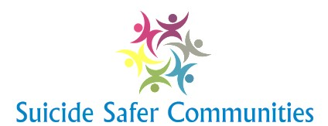

Local Suicide Safety Supports and Resources
Crisis (Distress) Line:
Suicide Prevention Center:
Headspace:
Rape/Sexual Assault Center:
Domestic Violence Hotline:
Mental Health Services:
Sexual Abuse Hotline:
Child Abuse Hotline:
Local Police Station:
Paramedic Emergency Medical Services: 000
Mental Health Crisis / Response - CATT:
Local Hospital Emergency:
Emergency Shelters:
Youth Shelter:
Mental Health Outreach Clinic:
Children/Youth Psychiatric Clinic:
Private Practitioners:
Medical Clinic / General Practitioner:
STD Information and Testing Sites:
Children’s Services Offices:
Student Services:
Child Care Referrals:
Parent Support and Training:
Family Support Services:
Self Help Groups:
Substance Abuse Counselling:
Alcoholics Anonymous:
Community Corrections Officers:
Religious/Spiritual Support:
Legal Aid/Victim-Witness Assistance:

